**Technical Solution Approach**

Contents

[1 Introduction 2](#_Toc127885736)

[1.1 About this document 2](#_Toc127885737)

[1.1.1 Purpose & Scope of the document 2](#_Toc127885738)

[2 Component Design 2](#_Toc127885739)

[2.1 Component Design Diagram 2](#_Toc127885740)

[2.1.1 Overall Workflow 2](#_Toc127885741)

[2.1.2 Low level Design](#_Toc127885742) 3

[3 Technology & Frameworks to be used](#_Toc127885743) 4

[4 Solution Approach](#_Toc127885744) 4

# Introduction

## About this document

### Purpose & Scope of the document

The dynamic UI components in Vue.js enables developers to create highly interactive and responsive applications. These components can be easily customized and reused, providing flexibility and consistency in the UI design. This helps to streamline development and enhance user experience. the key features of Vue.js is to make it an ideal framework for developing dynamic UI components, such as its reactivity system, component-based architecture, and the virtual DOM. Vitest is used for fast unit test which was powered by Vite of VueJS to reuse the configs,transformers and plugins consistent across the app And during tests.

# Component Design

## Component Design Diagram

### Overall Workflow

### Web capture_19-3-2023_181417_lucid.app

Fig 1.1

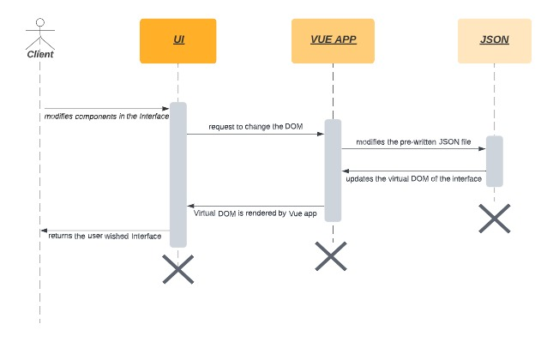

Fig 1.2

### Low level Design

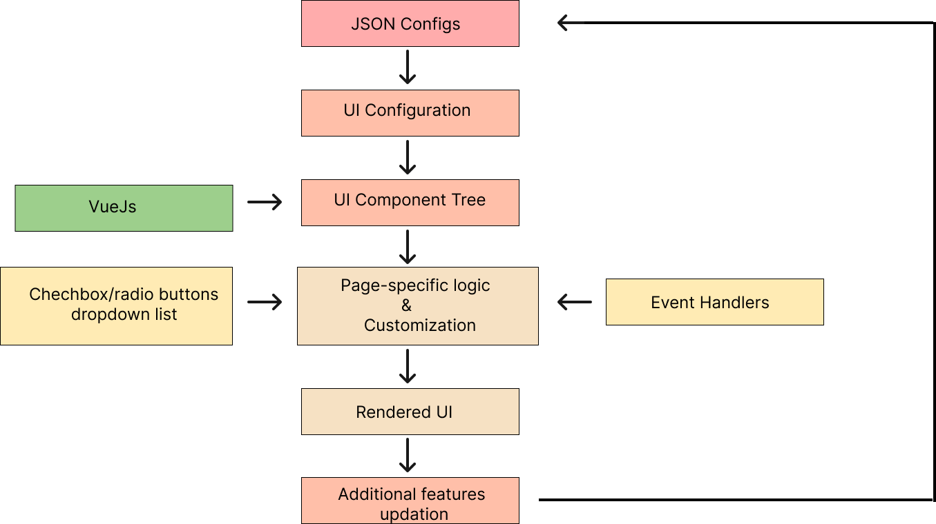 Fig 1.3

# Technology & Frameworks to be used

* HTML & CSS
* VueJS
* Javascript
* Vuex
* Vitest

# Solution Approach

1. Based on the general designs of web pages ,Reusable web page components will be created using VueJS .

2. The designed components will be stored in a library to fetch them for various activities and converted it to JSON format.

3. The UI component will be generated and rendered by the Vue’s virtual DOM after converting the JSON file as per the user changes made on the dynamic page loading time.

4. The UI component will use the information stored in JSON format to display on the web page .

5. This component’s styles,rendering HTML tags and modified views will be processed by Vue’s two-way binding of virtual DOM during the dynamic rendering.

6. The Exceptions and Errors specific to Vue..js which are within the Vue application scope will be handled by vue.config module and warning will be specified with onError dependency module.

7. The components will be developed in VueJS and Vuex file as a self-contained module.

8.The Vuejs-loger dependency of npm will be implemented to log the exceptions made by users and be stored in a separate JSON file

9. Vitest is used for unit testing the components which was powered by Vite of VueJS to reuse the configs,transformers and plugins consistent across the app And during tests.